**Personal Branding Workshop (Arpit Agrawal)**

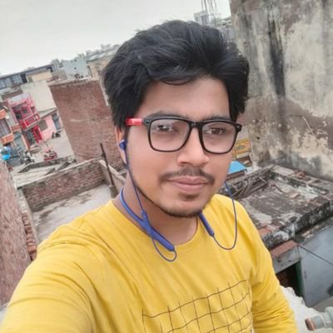**First Exercise**

1. open-source enthusiast
2. music lover
3. learner
4. 19-year-old
5. Lives in India
6. Learning Flute
7. Foody
8. Loves travel
9. Somewhat introvert
10. loves cycling
11. trying to lose Weight
12. learning in public
13. loves to read novels
14. loves to repair electronic stuff
15. provides good IT Support (windows)
16. loves to learn and try new things
17. learning how to build personal brand
18. trying to build personal brand
19. trying public speaking
20. interacting with folks
21. nowadays learning about how the people I admire achieve their   
     goals.
22. Learning from their and my own mistakes
23. Trying to set a new comfort zone and pushing my limits
24. Getting Involved with communities
25. Student
26. **I Am Enough for me (this line just keeps me on track)**

**2nd Exercise**

1. Learning Flute (my first musical Instrument)
2. Trying to set a new comfort zone and pushing my limits
3. Getting Involved and interacting

**3rd Exercise**

1. Can **Master** flute and start my own music production company (Global Level).
2. Accomplish my Aims and satisfies the crazy kid inside me.
3. Can **Get** and **Create** opportunities for everyone no one ever thought off.

**4th Exercise**

1. Sometimes it is fear being judged
2. Sometimes it is Procrastination
3. Sometimes it is not getting the right person to Learn From.

**5th Exercise**

Because If I don’t believe in myself then I can’t expect anyone to believe in me. Believe is not what can be made in one day, it comes from confidence that one gains by taking Actions from himself.

**6th Exercise**

1. Asking my crush out, taught me to stop overthinking and take the first step and rest all things fall in Place.
2. Living in College Hostel for the first time taught me to manage things alone, how to speak with people and how to identify people.
3. Getting Involved in Communities, interacting with new Folks and people across the globe with their awesome and worst experiences, this changes my way of looking at things, and also improves my communication skills.

**7th Exercise**

1. Providing IT Support (Windows)
2. Review Products and recommending those
3. Reading Novels

**8th Exercise**

1. Designing (Love it but I take a lot of time in deciding what to do)
2. Starting a Conversation
3. Sports (maybe master one sometime)

**9th Exercise**

I want to be a SDE with side by side doing content creation, for that I am Starting with involving with communities, Learning skills etc.

**10th Exercise**If you are looking for a person who is **focused and energetic** and who can **manage and keep the track of every detail of the work in the team and tries to maintain a constant flow** than contact me.

If you are looking for a someone who can **Lead the team,** I am happy to try, but perhaps you should talk to someone else.

Now Who am I?

I am a student who is highly energetic and never hesitates to push his limits, trying different domains, learning from my and others mistakes and improving myself.